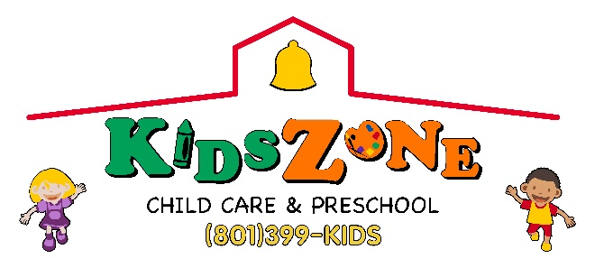

Admission Agreement Form
Mother or Guardian’s Name________________________________________ Cell phone_____________________________________
Employer_______________________________________________________ Work phone___________________________________
Father or Guardian’s Name_________________________________________ Cell Phone_____________________________________
Employer_______________________________________________________ Work phone___________________________________
Home Address___________________________________________________ City_________________State___________Zip_______
Besides the parents listed above and the emergency contacts listed below, who else is allowed to pick up your child? They will be required to show a photo ID_____________________________
Emergency contacts (parents will be called first, if parents are unavailable, we will call the contacts below. Please include one out of area contact for your child’s added safety)
- Name_________________________________________ Phone______________________________________
Address_______________________________________ Relationship to child__________________________
- Name_________________________________________ Phone______________________________________
Address_______________________________________ Relationship to child__________________________
- Name_________________________________________ Phone______________________________________
Address_______________________________________ Relationship to child__________________________

Child 1- Health Assessment & Medical Release
Name of child_________________________ Nickname___________ Birthdate___/___/___ Gender M or F Enrollment Date___/___/___
Doctor’s Name___________________________________________Phone___________________________________________________
Any known food, medication or other allergies or sensitivities No Yes (please list) ____________________________________________
Any chronic illnesses, disabilities or medical conditions No Yes (please list) __________________________________________________
Any additional health information not listed above______________________________________________________________________
Any routine medications your child is taking No Yes (please list names of medications) ________________________________________
Possible side effects or interactions with other drugs_____________________________________________________________________
☐ Check here after you have attached child’s current immunizations records. State daycare guidelines requires the child to be up to date before we can accept them.
Does this child need transportation to public school (Please circle): No Yes (if yes, complete the following)
School _____________________________________ Grade_____________ Traditional Track A Track B Track C Track D

Child 2- Health Assessment & Medical Release
Name of child_________________________ Nickname___________ Birthdate___/___/___ Gender M or F Enrollment Date___/___/___
Doctor’s Name___________________________________________Phone___________________________________________________
Any known food, medication or other allergies or sensitivities No Yes (please list) ____________________________________________
Any chronic illnesses, disabilities or medical conditions No Yes (please list) __________________________________________________
Any additional health information not listed above______________________________________________________________________
Any routine medications your child is taking No Yes (please list names of medications) ________________________________________
Possible side effects or interactions with other drugs_____________________________________________________________________
☐ Check here after you have attached child’s current immunizations records. State daycare guidelines requires the child to be up to date before we can accept them.
Does this child need transportation to public school (Please circle): No Yes (if yes, complete the following)
School _____________________________________ Grade_____________ ☐Traditional ☐ Track A ☐Track B ☐Track C ☐ Track D
____(Initial) Permission to transport to medical facility: I give permission for the staff at Kids Zone, to allow my children to be treated by emergency personal in case of emergency or serious illness, when parents cannot be reached immediately. I authorize Kids Zone staff to obtain emergency medical care and/or provide emergency medical transportation for my children.
____(Initial) Permission to administer medication: I give permission for the Kids Zone director or designee to administer regular medication(s) to my children according to the instructions above. I understand that medication will be administered during lunch hour. I agree that Kids Zone or its staff will not be held liable for any illness or injury resulting for administration or medication and will not be held responsible for the reimbursement of any medical expenses resulting from such action.
____(Initial) Permission to transport to public schools & field trips: I give permissions for my children to participate in the transportation and field trip program at Kids Zone. I agree to hold the center, it’s employees and/or volunteers harmless in the event of an accident to my children. I understand that transportation will be provided by a Kids Zone employee in a Kids Zone vehicle. I also understand that occasionally the children may walk to a park near our school.
____(Initial) Personal supplies for children: I agree to supply diapers and wipes for my children as needed. I agree to bring a change of clothes for my children four and under daily. I agree to bring a blanket for my child/children under five years for daily rest. Note: If you child is enrolled in full-time daycare you may leave a change of clothes and small blanket at Kids Zone.
____(Initial) Past Due Account: My account should be paid one week in advance to avoid past due charges. If my account is sent to collections, I understand that I will be responsible for collection cost of an additional 40 percent of the account balance, attorney fees, court cost and any other collection fees that may be incurred.
Signature of parent or guardian, by signing here I agree to the policies in the agreement: ____________________ Date: ________
Annual review | Date:__/__/__Initial:___ | Date:__/__/__Initial:___ | Date:__/__/__Initial:___ | Date:__/__/__Initial:___

